Description: Description: Description: Description: Description: Description: Description: Description: Description: Description: logocrosscheck

**Synthesis of Polybenzoxazine as an environmentally friendly adhesive material from cardanol and post-consumer PET source**

**Luong Viet Chat1, 2, Huynh Khanh Tuong1, 2, Du Ngoc Uy Lan3, Cao Xuan Viet1, 2, \***

1Department of Polymer Materials, Faculty of Materials Technology, Ho Chi Minh City University of Technology (HCMUT), 286 Ly Thuong Kiet Street, District 10, Ho Chi Minh City, Viet Nam

2Vietnam National University Ho Chi Minh City, Linh Trung Ward, Thu Duc Dist., Ho Chi Minh City, Viet Nam

3San Jacinto College - South Campus Chemistry - Physical Sciences, 13735 Beamer Road Houston, TX 77089, United States

*Emails: *caoxuanviet@hcmut.edu.vn*

Received: 15 July 2023; Accepted for publication: 8 July 2024

**Abstract.** In this study, a thermosetting benzoxazine was successfully prepared from environmentally friendly sources to be used as an adhesive. The phenolic component used for the synthesis of the benzoxazine monomer is cardanol derived from the cashew nutshell, while the amine fractions are terephthalamide, which is a product of the amination process of used polyethylene terephthalate plastic bottles (PET). The structure of the benzoxazine monomer was determined by FT-IR and 1H-NMR spectroscopy. The thermal and curing behavior of the materials was investigated by differential scanning calorimetry (DSC) and thermogravimetric analysis (TGA). A lap-shear adhesion testing (ASTM D1002-10) was performed to measure the bond strength of the material to the CT3 steel surface. The adhesive properties with a shear strength of 7.29 MPa are excellent compared to other commercial adhesives. This result indicates the great potential of this benzoxazine for adhesive applications in practice.

# *Keywords:* Cardanol, benzoxazine, post-consumer Polyethylene terephthalate, adhesive.

*Classification numbers*: 2.3.2, 2.9.4, 2.10.3.

1. Introduction

Adhesive materials (adhesives) bring many advantages over joining techniques such as sewing, mechanical joining (joining details with nails, screws, ...), etc [1]. The advantage of adhesive is that it can reconnect different materials, effectively distribute stress along the joint position, improve esthetics and increase flexibility in design. Adhesives can be classified according to their chemical composition, adhesion mechanism, such as pressure-sensitive adhesives, and adhesion [2-4]. Some common examples are epoxy adhesives: These adhesives are based on epoxy resins as a polymer matrix and provide excellent adhesive strength but require a long time to fully cure [5]. Polyurethane adhesives: These adhesives are widely used due to their versatility. They offer excellent bond strength, flexibility and impact resistance, but have a strong odor when in liquid form [6]. Cyanoacrylate adhesives: also known as instant adhesives, these are fast-curing adhesives that form strong bonds with a variety of materials. They are commonly used for precise and instant bonding [7]. However, their heat resistance is low. In this context, benzoxazine is expected to provide excellent adhesive strength while being heat resistant. Benzoxazine belongs to a subclass of phenolic resins that are synthesized from formaldehyde, an amine group, and a phenoxide group [8].

In this study, cardanol (a compound found in cashew nutshell liquid (CNSL)) was used as a phenolic source for the synthesis of benzoxazines. The use of bio-based materials as an alternative to petroleum-based feedstocks is considered to be extremely attractive. The hydrocarbon chain present in cardanol acts as an intramolecular plasticizer and imparts flexibility to the benzoxazine monomer due to the long chain structure of the alkyl chain, which greatly improves the ductility and flexibility of benzoxazines [9-10]. However, cardanol-based benzoxazine monomers usually have high viscosity and require higher curing temperatures due to their long and complex molecular structure [11]. In contrast, the amine fractions, terephthalamides, have a long chain structure and amide groups that give them flame retardancy, chemical resistance and excellent mechanical properties [12].

The combination of terephthalamide with cardanol and paraformaldehyde not only provides sustainability in the synthesis process, but also improves the overall performance of the resulting benzoxazine materials. The material is used as a sustainable adhesive. The shear test results (ASTM D1002-10) show that the adhesive properties of benzoxazine are excellent with a shear strength of 7.29 MPa compared to other commercial adhesives. This work contributes to the development of environmentally friendly and sustainable solutions in the field of thermosetting resin materials.

2. MATERIALS AND METHODS

2.1. Materials

The source PET is obtained from used plastic bottles. After collecting and removing the label, it is cut into small pieces of 5-10 mm. The PET fragments are then washed with water and acetone and then dried at a temperature of 60 ℃ for 24 hours before being used for the reaction. Cardanol obtained by distillation from Son Chau (Vietnam) Co, Ltd (M = 304 g/mol, ρ = 0.9363 g/cm3 (in 25 ℃), water content < 0.1 %, hydroxyl value 184.4 mg KOH/g, acid value 0.8 mg KOH/g, kinematic viscosity at 25 ℃ 51.47 mm2/s). For shear bond strength testing, CA-FU (benzoxazine synthesized from cardanol, formalin and urotropine), commercial epoxy adhesive (EPON™ Resin 828) and curing agent (EPIKURE™ Curing Agent 3230), commercial cyanoacrylate adhesive (3M™ Scotch-Weld™ SF100) was used. Other chemicals (paraformaldehyde, ethylenediamine, chloroform, acetone, ethanol, sodium hydroxide, sodium sulfate) are from Chemsol (Viet Nam).

2.2. Methods

Aminolysis of PET

The reaction of PET with ethylenediamine (EDA) was carried out according to the procedure described [13]. PET and EDA were reacted in a 250 ml round bottom flask at a molar ratio of 1:8 at 100 °C for 12 hours as shown in Fig. 1. The reaction mixture was then cooled to room temperature and ethanol was added to dissolve the components. The solution was filtered through a 50-micron steel mesh to remove unreacted PET fragments. A PET conversion efficiency of 87 % was achieved.

The terephthalamide mixture obtained from the aminolysis of PET consists of bis-aminoethyl terephthalamide (BAT) and α,ω-aminoligo ethylene terephthalamide (AET). These two compounds can be separated due to their different solubility in ethanol. The mixture was refluxed in ethanol for 2 hours, and then filtered after cooling to room temperature. The insoluble material was thoroughly rinsed with acetone and dried at 60 °C to obtain AET, while the soluble fraction was BAT.



*Figure 1.* Aminolysis of PET.

PET conversion efficiency:

$${PET}_{Conversion}(\%)=\frac{M_{PET initial}-M_{PET residual}}{M_{PET initial}}×100$$

Synthesis of benzoxazine (C-AET) from AET

AET, cardanol, and paraformaldehyde were combined in a molar ratio of 1:2:4. Cardanol was heated gradually to 80 ℃ for 1 hour with constant stirring. After that, AET and paraformaldehyde were added to the reaction flask and reacted at 100 ℃ for 4 hours. Water was formed during the reaction and the color of the solution gradually changed from yellow to reddish-brown. The mixture was cooled to room temperature and dissolved in chloroform at a ratio of 1:5. Excess cardanol was removed with a 0.5 N NaOH solution at a sample-to-NaOH volume ratio of 3:1. The cardanol formed a precipitate with NaOH and a floating organic layer is obtained, which was then removed and washed several times with distilled water. Sodium sulfate was used to absorb water from the solution. The solution was then filtered to remove the sodium sulfate. Finally, the mixture was dried under pressure to remove the solvent and obtain cardanol-based benzoxazine (C-AET) within 89 % yield.



*Figure 2.* Benzoxazine is synthesized from AET, cardanol and paraformaldehyde.

Preparation of samples for lap-shear adhesion testing

The adhesion of benzoxazine and other resins was tested on the surface of carbon steel (CT3). The steel surface was treated with coarse sandpaper (P60) to remove severe rust and with finer sandpaper (P150) to finish the surface. The resin was applied to the steel surface (20 mm x 20 mm), using a 0.1 mm pad between the two surfaces to create an adhesive layer about 0.1 ± 0.05 mm thick (Fig. 3). The samples were clamped tightly with a staple and heated from 80 ℃ to 190 ℃ for 30 minutes, and then held at 190 ℃ for 1 hour to achieve complete curing of the samples. For the other adhesive samples, the same procedure was applied with different curing conditions as follows:

- Benzoxazine (CA-FU): cured for 1 hour at 100 ℃, heated and fully cured in 3 hours at 200 ℃.

- Epoxy (EPON™ Resin 828): The ratio of resin to hardener is 3:1 and cured at room temperature. The sample is stable after 24 hours.

- Cyanoacrylate (3M™ Scotch-Weld™ SF100): cured at room temperature and the specimen is stable after 24 hours.

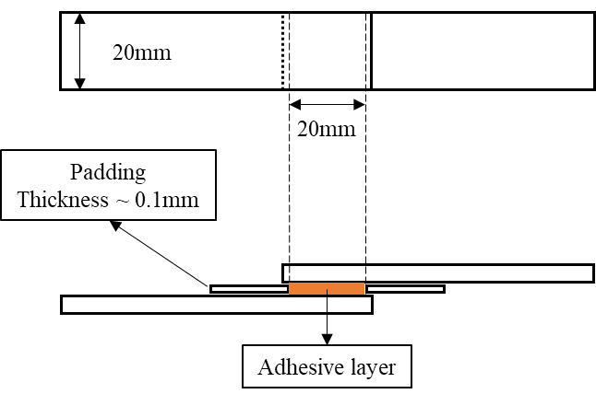

*Figure 3.* Samples for lap-shear adhesion testing.

2.3. Characterizations

The Fourier transform infrared (FT-IR) spectra were recorded with a Bruker Tensor37 spectrophotometer with a resolution of 4000 – 400 cm-1. The measurement was carried out at the Institute of Chemical Technology, Vietnam Academy of Science and Technology (VAST), Ho Chi Minh City.

1H-NMR spectroscopy was carried out in deuterated dimethyl sulfoxide (DMSO) and tetramethylsilane (TMS) as internal standards using a Bruker Avance 500 MHz. The NMR measurements and analyzes were carried out at the Center for Application Spectroscopy, Institute of Chemistry, Vietnam Academy of Science and Technology (VAST), Ha Noi.

The thermal behavior (DSC and TGA) of the benzoxazine samples was examined using a differential scanning calorimeter (DSC) on a Labsys EVO (TGA-DSC 1600 ℃) from SETARAM Instrumentation, Ho Chi Minh City University of Education. The experiments were carried out in dynamic mode under N2 atmosphere and with a heating rate of 10 ℃/min from room temperature to 600 ℃. A sample mass of 10.0 ± 0.5 mg was used for each experiment.

The bond strength (to CT3 steel) of polybenzoxazines formed by curing AET monomer as well as other resins was determined according to ASTM D1002-10 Standard Test Method for Apparent Shear Strength of Single-Sided Bonded Metal Specimens by Tensile Loading (Metal to Metal) using Testometric M350 10CT universal testing machine measured in the rubber laboratory of Ho Chi Minh City University of Technology. At least 5 samples were tested and the average values were determined.

3. Results and Discussion

3.1. Aminolysis of PET

The FT-IR analysis of PET (Fig. 4) revealed the following results: There is no absorption peak at around 3286 cm-1 (-NH, stretching vibration). At the same time, the absorption peak at 1713 cm-1 (-C=O, stretching vibration) in the ester linkage of PET, is no longer observed in the FT-IR spectrum of AET. Instead, two characteristic absorption peaks occur at 1631 cm-1 and 1546 cm-1, corresponding to -C=O and -NH, respectively. This indicates that PET undergoes aminolysis leading to the formation of amide groups. Bands at 1631 cm-1 (-C=O, stretching), 1546 cm-1 (-NH, bending), 3286 cm-1 (-NH, stretching) were also observed in the amide. The band at 3344 cm-1 (symmetric stretching) is characteristic of aliphatic amines, especially RCH2NH2. This band apparently does not appear on FT-IR of AET, although AET still contains terminal NH2 groups, indicating that the concentration of the primary amine group is not significant.

*Figure 4.* FTIR spectra of PET and AET.

1H-NMR (Fig. 5) spectra analysis spectroscopy of AET shows the following characteristic peak: resonances at δ = 7.907 ppm (e, aromatic), δ = 2.691 ppm (b, CONHCH2CH2NH2), δ = 3.265 ppm (c, CONHCH2CH2NH2), δ = 8.711 ppm (d, CH2NHCO), δ = 8.459 ppm (f, CONHCH2CH2NHCO), δ = 3.446 ppm (g, CONHCH2CH2NHCO).

*Figure 5.* 1H-NMR spectra of AET.

3.2. Cardanol and AET derived benzoxazine (C-AET) synthesis

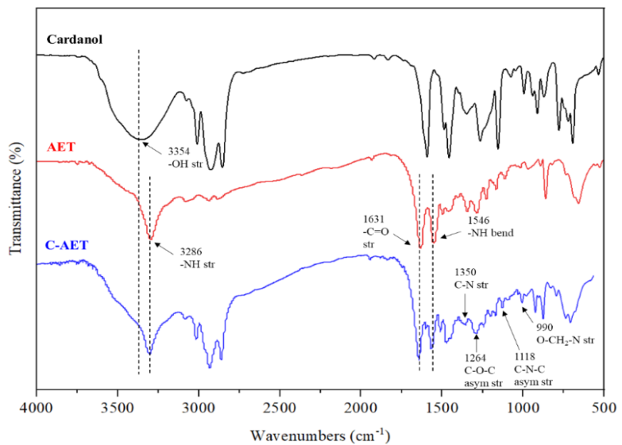The results of the FTIR infrared spectra of Cardanol, AET, and C-AET are shown in Fig. 6. The spectrum of C-AET no longer shows the signal of the peak at 3354 cm-1, which is characteristic of the vibration of the -OH group present in Cardanol. It can be concluded that complete conversion of the OH groups in Cardanol has occurred, leading to the formation of the oxazine ring in C-AET. Analysis of the FT-IR infrared spectra of C-AET reveals characteristic absorptions for the oxazine ring at 1350 cm-1 (C-N, stretching vibration), 1264 cm-1 (C-O-C, asymmetric stretching vibration), 1118 cm-1 (C-N-C, asymmetric stretching vibration), 990 cm-1 (O-CH2-N, stretching vibration), all of which is present in the oxazine ring. Furthermore, when comparing the FT-IR analysis results, characteristic peaks representing the structure of AET in C-AET are still observed, such as the peak at 1631 cm-1 (-C=O, stretching vibration), 1546 cm-1 (-NH, bending vibration), 3286 cm-1 (-NH stretching vibration) in the amide group.

*Figure 6.* FTIR spectra of cardanol, AET, C-AET.

The 1H-NMR of the benzoxazine resin C-AET is presented in Fig. 7. The resonance at position a, (δ = 5.399-5.424 ppm) is a multiplet peak characteristic of the H of ArOCH2N in the oxazine ring. Position b, (δ = 4.705 ppm) exhibits a singlet peak characteristic of the H of ArCH2N. The intensity ratio of the signals associated with the oxazine ring at around 4.7 ppm (singlet peak) and 5.4 ppm (multiplet peak) is expected to be 1:1 [8]. However, the current study shows a higher, similar ratio. This can be explained by the resonance of the alkylene protons present in cardanol at positions h (CH=, CH2=CH-) in the same position as ArOCH2N. In addition, some resonance characteristics of the hydrocarbon chain present in cardanol at δ = 0.907 ppm (l, CH3/CH2), δ = 1.257-1.368 ppm (f, -CH2-), δ = 1.581 ppm (e, -CH2-CH2-Ar), δ = 2.015 ppm (g, CH2-CH=CH), δ = 2.773-2.821 ppm (d, CH2-Ar), δ = 3.002 ppm (I, CH=CH-CH2-CH=CH-), δ = 4.968-5.139 ppm (k, CH=CH2), δ = 5.874 ppm (j, CH=CH2), δ = 6.626-6.728 ppm (c, Ar-H).

*Figure 7.* 1H-NMR spectra of C-AET.

*Figure 8.* DSC of benzoxazine resin C-AET a) Not cured yet, b) cured 30 min, c) cured 60 min.

DSC analysis was employed to investigate the curing behavior of C-AET from room temperature to 300 °C. In Fig. 8a, an exothermic peak is observed over an extensive temperature range, commencing at 120.54 °C and concluding at 277.57 °C, with the apex at 189.32 °C. This exothermic peak is attributed to the ring-opening temperature of the benzoxazine monomer (C-AET). In Fig. 8b, the C-AET sample, cured for 30 minutes, still exhibits the presence of the exothermic peak, but it occurs within a narrower temperature range. However, in Fig. 8c, the exothermic peak is no longer observed in the fully cured C-AET sample, which was heated at 190 °C for 60 minutes.

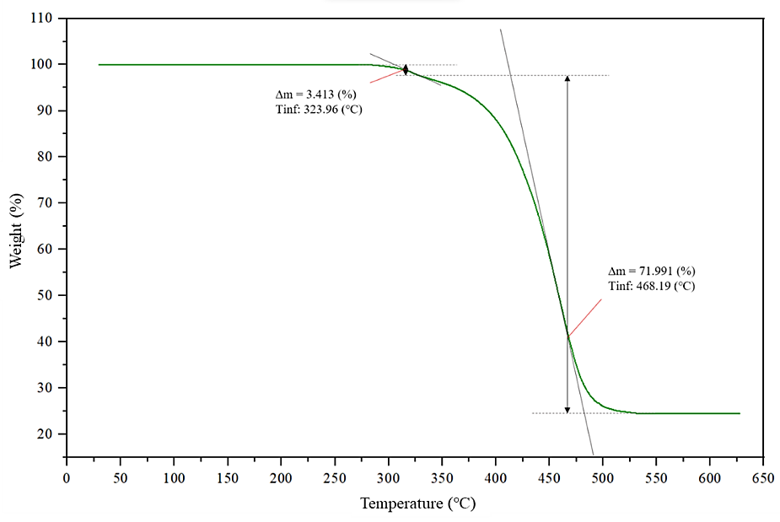The thermal stability of fully cured polybenzoxazine C-AET was assessed by monitoring the sample's weight loss using thermogravimetric analysis (TGA). Fig. 9 reveals that no weight loss is observed at temperatures below 250 °C, indicating that the cured benzoxazine resin exhibits high thermal stability. The absence of traces of water evaporation implies that the curing process occurred without by-products and that the resin is not reactive to moisture from the environment. The first weight loss step initiates at 290 °C and concludes at 328 °C, resulting in a weight loss of 3.413 %. The peak of this process is observed at 323.96 °C, as per the TGA measurement graph. This can be attributed to the high temperature causing the cleavage of -OH groups on the phenol ring, as well as the bonds in the Mannich bridge C-N-C present in the benzoxazine [14]. The second weight loss step exhibits a significant weight reduction of approximately 72 %, starting at around 328 °C and ending at 530 °C. The peak of this process is observed at 468.19 °C, according to the TGA measurement graph. The weight loss is attributed to the degradation of the hydrocarbon chain, benzene rings, and amide bonds in the molecular structure. The residual ash content after the thermal degradation process is 24.59 %.

*Figure 9.* TGA of benzoxazine resin C-AET.

3.3. Lap-shear adhesion testing

The adhesion of the adhesive bonded to metal surfaces was determined according to ASTM D1002-10 standard. The lap-shear strength of polybenzoxazine C-AET was compared with Benzoxazine (CA-FU) synthesized from cardanol, formalin, and urotropine [15], as shown in Fig 10. Commercial epoxy adhesive (EPON™ Resin 828) and curing agent (EPIKURE™ Curing Agent 3230) are depicted in Fig. 11. Additionally, commercial cyanoacrylate adhesive from 3M (3M™ Scotch-Weld™ SF100) is presented in Fig. 12. The adhesion mechanism of all four types of adhesive products is determined by both physical and chemical factors. The physical factor is related to the wetting ability of the surface-treated steel when evaluating adhesion strength. However, the primary factor determining the adhesion capability on metal surfaces is the difference in the molecular structure of the adhesive products.

*Figure 10.* The structure of CA-FU.





*Figure 11.* a) Epoxy (EPON™ Resin 828), b) Curing agent (EPIKURE™ Curing Agent 3230).



*Figure 12.* Cyanoacrylate (3M™ Scotch-Weld™ SF100)

*Table 1.* Lap-shear strength of C-AET, CA-FU and some commercial adhesive.

|  |  |
| --- | --- |
| *Sample of adhesive* | *Lap-shear strength (MPa)* |
| C-AET | 7.29 ± 0.35 |
| CA-FU | 2.13 ± 0.03 |
| EPON™ Resin 828 | 6.02 ± 0.18 |
| 3M™ Scotch-Weld™ SF100 | 8.61 ± 0.56 |

Table 1 shows the lap-shear strength adhesion of each type and indicates that benzoxazine C- AET, which is obtained from AET, cardanol, and paraformaldehyde, has 3.42 times higher lap-shear strength than benzoxazine obtained from cardanol, formalin, and urotropine (CA-FU). Both types of benzoxazine are synthesized from cardanol, with the long hydrocarbon chain present in cardanol. The curing reaction due to the opening of the oxazine ring under high temperature leads to the formation of - OH groups present in phenol in both C- AET and CA-FU. This is considered to be a crucial factor for the adhesion of benzoxazine to metal surfaces. However, C- AET contains a high number of polar amide groups in its molecular structure. This is the main distinguishing factor between the two types of benzoxazine, suggesting that the flexibility of the function group in the material structure significantly affects the properties of benzoxazine.

Benzoxazine C-AET exhibits higher lap-shear strength compared to a commercial epoxy adhesive (EPON™ Resin 828). This can be explained by considering the structural similarities between C-AET and commercial epoxy resin with multiple benzene rings in the molecular structure. During curing, a network structure is formed and -OH groups are formed, which improve adhesion to metal surfaces. However, as mentioned above, C-AET contains a significant number of polar amide functional groups that enhance adhesion to metal surfaces.

The lap-shear strength of C-AET is lower than a commercial cyanoacrylate adhesive (3M™ Scotch-Weld™ SF100). This is because cyanoacrylate adhesive contains highly polar nitrile (-CN) functional groups that provide excellent adhesion to material surfaces. In addition, due to its low molecular weight, the curing process of cyanoacrylate adhesive forms high molecular weight polymers with densely packed -CN groups. However, the disadvantage of cyanoacrylate adhesives is that they cannot maintain high adhesive strength at high temperatures (< 80 ℃).

4. Conclusions

Synthesis of benzoxazine from α,ω-aminoligo (ethylene terephthalamide) (AET), cardanol, and paraformaldehyde, with a molar ratio of 1:2:4, respectively was successfully carried out with a reaction time of 4 hours at 100 ℃, achieving an 89 % yield. The molecular structure of the benzoxazine monomer was confirmed by FT-IR and 1H-NMR analysis. The curing condition of the C-AET polymer for lap-shear test was 190 ℃ for 60 min based on the DSC results. The TGA data indicated that C-AET polybenzoxazine was thermally stabilized up to nearly 300 ℃. The lap-shear test of the C-AET on CT3 steel surfaces shows an adhesive strength of 7.29 MPa which is quite impressive compared to other commercial adhesives. The combination of terephthalamide, cardanol, and paraformaldehyde offers a sustainable and efficient route for the synthesis of benzoxazine materials with enhanced properties and highlights the potential practical applications of C-AET.

**Acknowledgements.** We acknowledge the support of time and facilities from Ho Chi Minh City University of Technology (HCMUT), VNU-HCM for this study.

***Credit authorship contribution statement.*** Luong Viet Chat: performed the experiments, analyzed and interpreted the data, and wrote the paper; Cao Xuan Viet: conceived and designed the experiments, analyzed and interpreted the data, and wrote the paper; Huynh Khanh Tuong analyzed and interpreted the data; Du Ngoc Uy Lan reviewed and edited the paper. All authors have read and agreed to the published version of the manuscript.

***Declaration of competing interest.*** The authors declare that they have no known competing financial interests or personal relationships that could have appeared to influence the work reported in this paper.

References

1. Kinloch A. J., Kinloch A. J. - Adhesion and adhesives: science and technology, Springer Science & Business Media, 1987.

2. Banea M. D., da Silva L. F., Campilho R. D., Sato C. - Smart adhesive joints: An overview of recent developments, The Journal of Adhesion **90** (1) (2014) 16-40. https://doi.org/10.1080/00218464.2013.785916

3. Onusseit H., Wefringhaus R., Dreezen G., Wichelhaus J., Schall J., Thiele L., van Halteren A. - Adhesives 1. general, Ullmann's Encyclopedia of Industrial Chemistry, 2010, 440-481. https://doi.org/10.1002/14356007.a01_221.pub3

4. Van K. N. - Chemical and technological adhesive, Publisher of Vietnam Academy of Science and Technology, 2006.

5. Schmidt R. G., Bell J. P. - Epoxy adhesion to metals, Epoxy resins composites II 2005, 2005, pp. 33-71.

6. Nečasová B., Liška P., Kelar J., Šlanhof J. - Comparison of adhesive properties of polyurethane adhesive system and wood-plastic composites with different polymers after mechanical, chemical and physical surface treatment, Polymers **11** (3) (2019) 397. https://doi.org/10.3390/polym11030397

7. Leggat P. A., Smith D. R., Kedjarune U. - Surgical applications of cyanoacrylate adhesives: a review of toxicity, ANZ journal of surgery **77** (4) (2007) 209-213. https://doi.org/10.1111/j.1445-2197.2007.04020.x

8. Sharma P., Lochab B., Kumar D., Roy P. K. - Sustainable bis-benzoxazines from cardanol and PET-derived terephthalamides, ACS Sustainable Chemistry & Engineering **4** (3) (2016) 1085-1093. https://doi.org/10.1021/acssuschemeng.5b01153

9. Voirin C., Caillol S., Sadavarte N. V., Tawade B. V., Boutevin B., Wadgaonkar P. P. - Functionalization of cardanol: towards biobased polymers and additives, Polymer Chemistry **5** (9) (2014) 3142-3162. https://doi.org/10.1039/C3PY01194A

10. Mohapatra S., Nando G. B. - Cardanol: a green substitute for aromatic oil as a plasticizer in natural rubber, Rsc Advances **4** (30) (2014) 15406-15418. https://doi.org/10.1039/ C3RA46061D

11. A Attanasi O., S Behalo M., Favi G., Lomonaco D., E Mazzetto S., Mele G., Pio I., Vasapollo G. - Solvent free synthesis of novel mono-and bis-benzoxazines from cashew nut shell liquid components,Current Organic Chemistry **16** (21) (2012) 2613-2621. https://doi.org/10.2174/138527212804004616

12. Wang X., Yu L., Liu Y., Jiang X. - Synthesis and fouling resistance of capsaicin derivatives containing amide groups, Science of The Total Environment **710** (2020) 136361. https://doi.org/10.1016/j.scitotenv.2019.136361

13. Hoang C. N., Dang Y. H. - Aminolysis of poly (ethylene terephthalate) waste with ethylenediamine and characterization of α, ω-diamine products, Polymer degradation and stability **98** (3) (2013) 697-708. https://doi.org/10.1016/j.polymdegradstab.2012.12.026

14. Khan M. M., Halder K., Shishatskiy S., Filiz V. - Synthesis and crosslinking of polyether-based main chain benzoxazine polymers and their gas separation performance, Polymers **10** (2) (2018) 221. https://doi.org/10.3390/polym10020221

15. Tuong H. K. - Investigation of Benzoxazine resin derived from cardanol on the properties of natural rubber compounds, Thesis, 2023, pp. 28-34.